Near-Duplicate Question Finder for Q&A Platforms
Project Report submitted for the partial fulfilment of grade for the course

Data Structures and Algorithms -3 (25CS2103E)
in

A.Y. 2026-2027

Submitted by
M Shashanth (2520090129)
M Akshay (2520090065)

Team Number:
Section: 11

Under the guidance of

Mrs. Ch. Anitha

Assistant Professor, CS&IT
Hyderabad-500090, Telangana, India.

K L (Deemed to be) University
DEPARTMENT OF COMPUTER SCIENCE AND INFORMATION TECHNOLOGY



DECLARATION

The Mini Project Report entitled “Near-Duplicate Question Finder for Q&A Platforms” is a record of Bonafide work of M Shashanth – 2520090129, M Akshay – 2520090065. The report is submitted in partial fulfillment for the award of B. Tech in Computer Science and Information Technology to the K L (Deemed to be) University. The results embodied in this report have not been copied from any other departments/University/Institute.

M Shashanth – 2520090129
M Akshay – 2520090065

K L (Deemed to be) University
DEPARTMENT OF COMPUTER SCIENCE AND INFORMATION TECHNOLOGY
CERTIFICATE

This is to certify that the mini project based report entitled “Near-Duplicate Question Finder for Q&A Platforms” is a bonafide work done and submitted by M Shashanth – 2520090129, M Akshay – 2520090065. in partial fulfillment of the requirements for the award of the degree of BACHELOR OF TECHNOLOGY in Department of Computer Science and Information Technology, K L (Deemed to be University), during the academic year 2026-2027.

Signature of the Supervisor

Signature of the HOD Signature of the External Examiner

ACKNOWLEDGEMENT

The success in this project would not have been possible but for the timely help and guidance rendered by many people. Our wish to express my sincere thanks to all those who has assisted us in one way or the other for the completion of my project.

Our greatest appreciation to our guide, Mrs. Ch. Anitha, Assistant Professor, Department of Computer Science and Information Technology, which cannot be expressed in words for her tremendous support, encouragement and guidance for this project.

We express our gratitude to Dr. Khaja Shareef (CS & IT), Head of the Department of Computer Science and Information Technology, for providing us with adequate facilities, ways and means by which we are able to complete this project-based Lab.

We thank all the members of teaching and non-teaching staff members, and also who have assisted me directly or indirectly for successful completion of this project. Finally, I sincerely thank my parents, friends and classmates for their kind help and cooperation during my work.

M Shashanth – 2520090129
M Akshay – 2520090065

TABLE OF CONTENTS

S.No. | Contents | Page no.
1. | Abstract | 6
2. | Introduction | 7
3. | Literature survey | 8
4. | Problem Statement and Objectives | 10
5. | Hardware and Software requirements | 11
6. | Implementation | 12
7. | Results & Discussion | 17
8. | Conclusion & Future Scope | 23
9. | References | 24

1.ABSTRACT
The Near-Duplicate Question Finder for Q&A Platforms is designed to identify similar and duplicate questions before they are added to a database, where duplicate content can increase redundancy and reduce search efficiency. The system preprocesses user questions using text normalization, tokenization, stop-word removal, and shingling to create a suitable representation for comparison. It uses HashMap and HashSet for efficient indexing and retrieval of question features, while Jaccard Similarity measures the similarity between the new question and existing questions. A Priority Queue is then used to rank the most similar questions based on their similarity scores. By displaying relevant existing questions to users, the system helps reduce duplicate content, improve information organization, and enhance the overall search experience on Q&A platforms.
Team Members:
- M Shashanth, 2520090129
- M Akshay, 2520090065
- INTRODUCTION

Question-and-answer (Q&A) platforms such as Stack Overflow and Quora hold thousands or even millions of questions across a wide range of topics. As the number of users grows, many of them post questions that are identical or very similar to questions that already exist. These questions may use different words, sentence structures, or writing styles even though they describe the same problem.
Exact string matching cannot identify most of these near-duplicate questions because the text is not exactly the same. Duplicate questions increase content redundancy, split answers across several threads and make it harder for users to find the most relevant information. Checking every new question manually against all existing questions is time-consuming and does not scale to large databases.
This project proposes an automated approach that is built from fundamental Data Structures and Algorithms (DSA). A new question is normalised, tokenised, stripped of stop-words and converted into a set of word shingles. A HashMap-based inverted index retrieves only those stored questions that share at least one shingle with the new question, HashSet operations compute the Jaccard similarity of each candidate, and a bounded Priority Queue (min-heap) keeps the Top-K most similar questions. The most relevant matches are then shown to the user before the question is posted.
Example. “How do I reverse a linked list in Java?” and “How can I reverse a Java linked list?” use different words and word order, yet they ask the same thing. After preprocessing both reduce to the keywords reverse, linked, list and java, so their shingle sets overlap strongly and the system ranks them as near-duplicates.
The project is delivered as a single-page website that runs entirely in the browser. Besides the duplicate detector, the website visualises every stage of the pipeline (preprocessing, inverted index, heap) and contains an Algorithm Lab that demonstrates the other course topics (string matching, edit distance, network flow, approximation and randomised algorithms) on the same data.
The rest of the report is organised as follows: Chapter 3 reviews related work, Chapter 4 states the problem and objectives, Chapter 5 lists the hardware and software used, Chapter 6 presents the implementation, Chapter 7 shows and discusses the results, and Chapter 8 concludes with the future scope.
- LITERATURE SURVEY

Duplicate and near-duplicate detection has been studied for web documents, for community question-answering sites and for machine-learning competitions. The approaches reviewed below are summarised first and then described in more detail. The reference numbers point to the URLs listed in the References section.
Approach | Technique | Limitation
Exact Matching | String comparison | Misses wording variations
Keyword Matching | Common keywords | Can produce irrelevant matches
Text Similarity | Set / vector comparison | Can become expensive at scale
Hash-based Methods | Hashing / indexing | Depends on representation
Proposed Approach | HashMap + HashSet + Jaccard + Priority Queue | Efficient candidate retrieval and ranking

1. On the Resemblance and Containment of Documents (Broder, 1997) [1]. This work introduced shingling: a document is represented as the set of its contiguous word sequences, and the resemblance of two documents is the Jaccard coefficient of their shingle sets. It also showed how small random samples (sketches) of these sets can estimate resemblance. Our project uses the same shingle-set and Jaccard idea on short questions, and the MinHash demonstration in our Algorithm Lab follows the sketch idea.
2. Syntactic Clustering of the Web (Broder et al., 1997) [2]. This paper applied shingling and resemblance to cluster near-duplicate web pages at web scale, using sketches so that documents need not be compared pair by pair. It shows that near-duplicate detection must avoid comparing every item with every other item. We follow the same principle with an inverted index so that only questions sharing a shingle are ever scored.
3. Mining of Massive Datasets, Chapter 3: Finding Similar Items (Leskovec, Rajaraman, Ullman) [3]. This textbook chapter explains shingling, Jaccard similarity, MinHash signatures and locality-sensitive hashing (LSH) for finding similar items in large collections. It is the theoretical base for our pipeline and for the future-scope items (MinHash and LSH), which would replace the exact set intersections when the question bank becomes very large.
4. Multi-Factor Duplicate Question Detection in Stack Overflow (Zhang et al., 2015) [4]. This work detects duplicate questions on Stack Overflow by combining several similarity factors drawn from the question text and its tags and ranking candidate duplicates. It confirms that ranking a list of candidate duplicates for the asker is a practical way to reduce duplicates. Our system also returns a ranked list but relies only on text overlap, which keeps it small, fast and explainable.
5. Mining Duplicate Questions of Stack Overflow (Kale, Rayasam, Parik, Dheram) [5]. The authors propose two neural-network architectures that detect duplicate Stack Overflow questions and explicitly model the code inside a question in addition to its text. Such models can capture more than word overlap but need training data and computing resources. Our DSA-based approach needs no training and its decisions can be inspected step by step.
6. Identifying Duplicate Questions on Quora, Top 12% on Kaggle (Srivastava) [6]. This write-up for the Quora Question Pairs competition builds about 70 features (word-overlap measures, distance metrics, word2vec vector distances and graph features of the question-pair network) and trains a single XGBoost model. It reaches the top 12% of the competition but is a pairwise classifier: it does not describe how to retrieve candidate questions from a large database, which is the role of our inverted index.
7. Siamese Neural Networks with Random Forest for Detecting Duplicate Question Pairs [7]. This study combines Gated Recurrent Units in a Siamese network with classifiers such as Random Forest, AdaBoost and SVM on the Quora data set of about 400,000 labelled question pairs. Its best model, a Siamese bidirectional GRU with Random Forest, ranked in the top 24% of the Kaggle competition. Deep models understand wording better than word overlap but are costly to train and hard to explain.
8. Handling Duplicate Questions (Stack Overflow Blog, 2009) [8]. The post describes how Stack Overflow deals with duplicates: copy-and-paste reposts are removed, accidental duplicates are closed and linked to the original question so that moderators can merge them, and borderline cases are left open and linked as related. It shows that the problem is real and is handled manually by the community today, which motivates an automatic suggestion before a question is posted.
Research Gap. Exact and keyword matching miss reworded questions, while machine-learning models are heavy to train and difficult to explain. A practical DSA-based approach is needed to efficiently retrieve and rank near-duplicate questions; this project fills that gap with hashing, sets and a priority queue.
- Problem Statement and Objectives

Problem Statement:
To develop an efficient system that identifies and ranks questions similar to a newly submitted question, reducing duplicate content and improving information retrieval in Q&A platforms.
Problem Description:
Users often post questions that were already asked in different words, so exact matching fails and comparing a new question with every stored question is slow. The system must preprocess the question, quickly retrieve only the relevant candidates, measure their similarity and present the best matches.
Objectives:
1. Preprocess incoming questions by normalising the text, tokenising it and removing stop-words.
2. Generate tokens and shingles (single words and word pairs) that represent each question as a set.
3. Efficiently retrieve candidate questions using a HashMap-based inverted index, instead of comparing against every question.
4. Calculate the similarity of each candidate with the new question using Jaccard similarity on HashSets.
5. Rank the similar questions with a Priority Queue (bounded min-heap) and return the Top-K results.
6. Suggest possible duplicates to the user, with a configurable duplicate threshold, before the question is posted.
- HARDWARE AND SOFTWARE REQUIREMENTS

Hardware Requirements:
- Laptop / Desktop computer
- 4 GB RAM (minimum)
- Processor: Intel i3 or equivalent and above
- Storage: 10 GB available
- Internet connection (optional – the website has no external dependencies and also works offline)

Software Requirements:
- Language: JavaScript (ES6+) with HTML5 and CSS3 – a single-page website with no libraries and no build step
- IDE / Editor: Visual Studio Code (with the Live Server extension, optional)
- Runtime for logic tests: Node.js (command: node test/run.js)
- Browser: any modern browser such as Google Chrome, Microsoft Edge or Firefox
- Database: none – the question bank is kept in memory and in the browser’s localStorage
- Operating System: Windows / Linux / macOS
- Git / GitHub (optional) for version control
- IMPLEMENTATION

The system is implemented in plain JavaScript. All core data structures (HashMap, HashSet, MinHeap, bounded Top-K queue) are written by hand in js/ds.js and no built-in Map, Set or sort is used by the engine. The four main modules are shown below as screenshots of the source code, each followed by a screenshot of its output.
Module 1: Text preprocessing and shingling (js/text.js)
The question is lower-cased, punctuation is replaced by spaces, the text is split into tokens, stop-words are removed using a HashSet and the remaining tokens are turned into unique word shingles. Each shingle is hashed with a double polynomial hash.
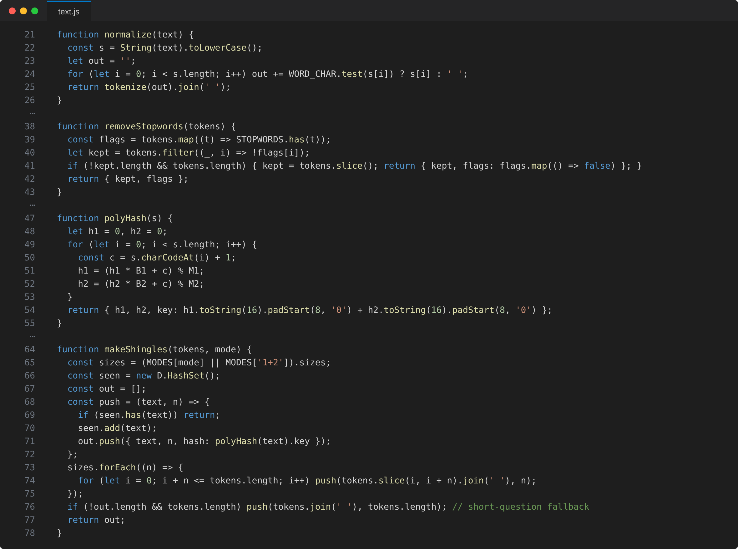
Figure 6.1: Source code of Module 1 (js/text.js)
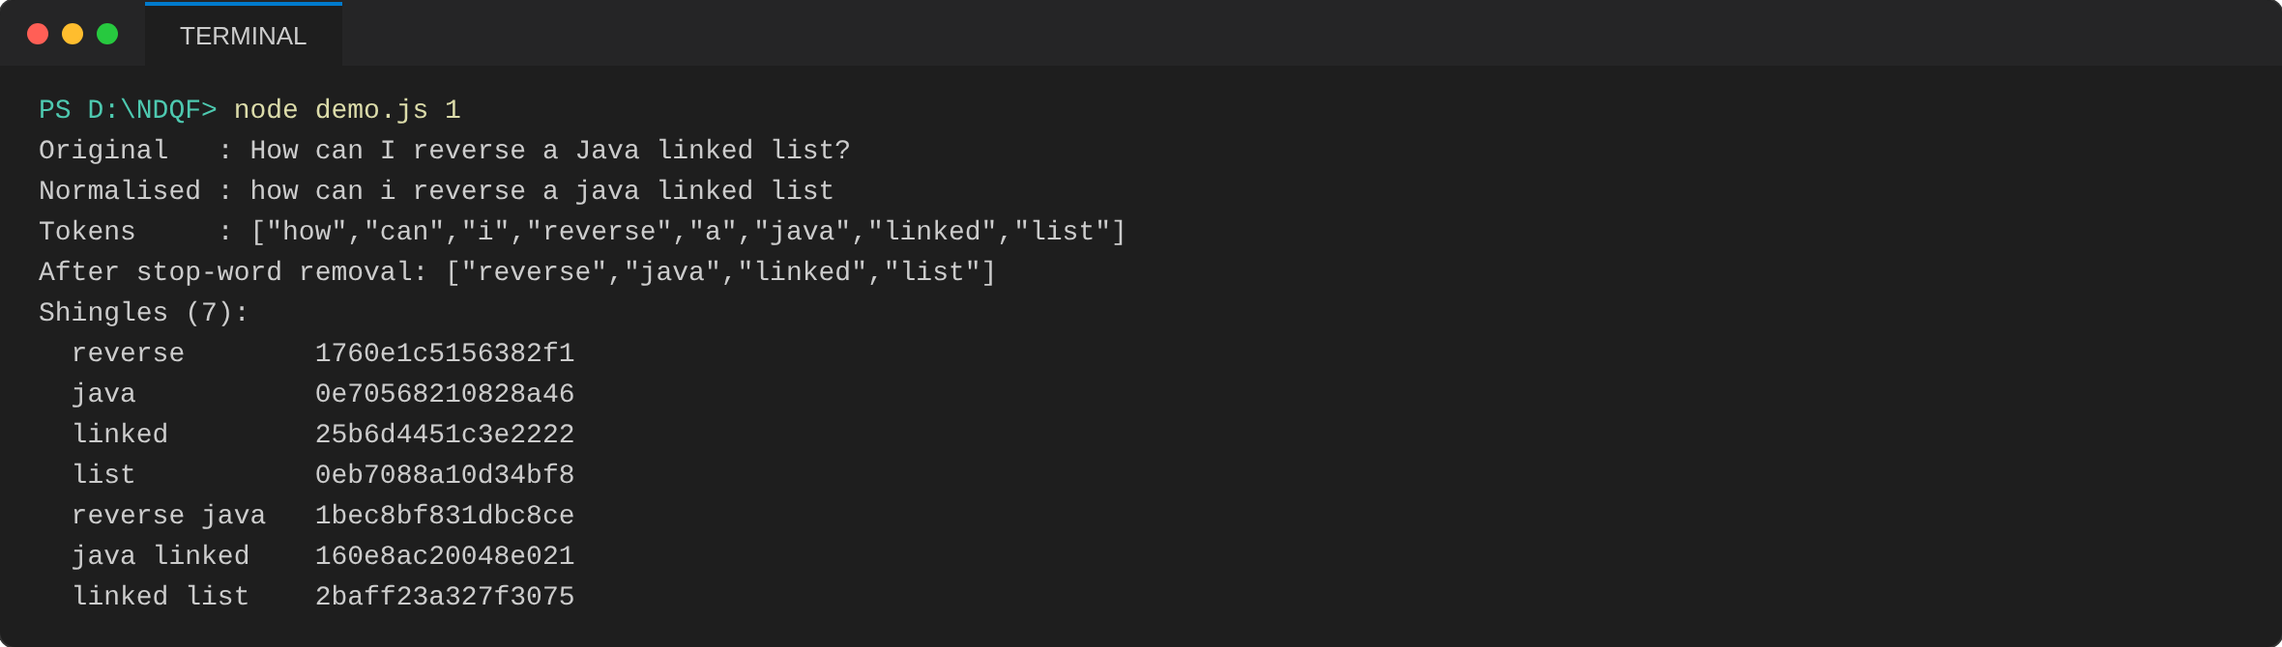
Figure 6.2: Module 1 output: preprocessing and shingling of “How can I reverse a Java linked list?”
The output shows the normalised text, the tokens, the four keywords left after stop-word removal and the seven shingles with their 16-digit hash keys.
Module 2: HashMap, HashSet and Jaccard similarity (js/ds.js)
The HashMap uses separate chaining with a prime capacity and resizes when the load factor exceeds 0.75. The HashSet is built on the HashMap, and Jaccard similarity is computed as |A ∩ B| / |A ∪ B| by iterating over the smaller set.
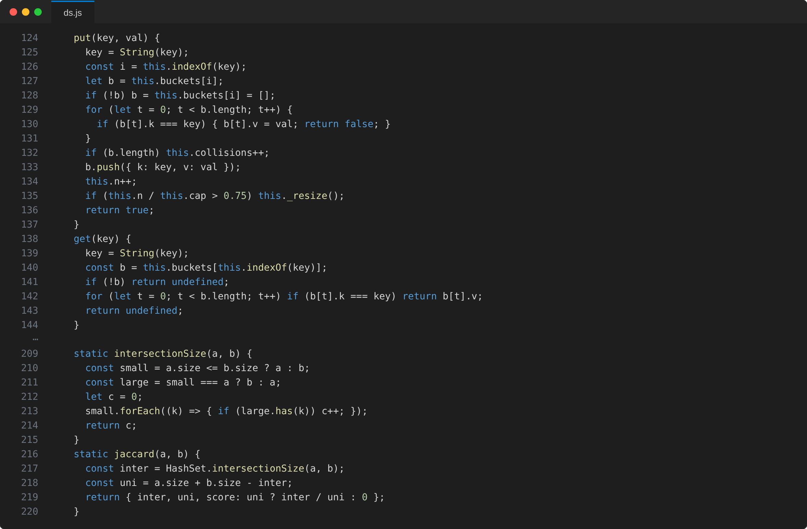
Figure 6.3: Source code of Module 2 (js/ds.js)
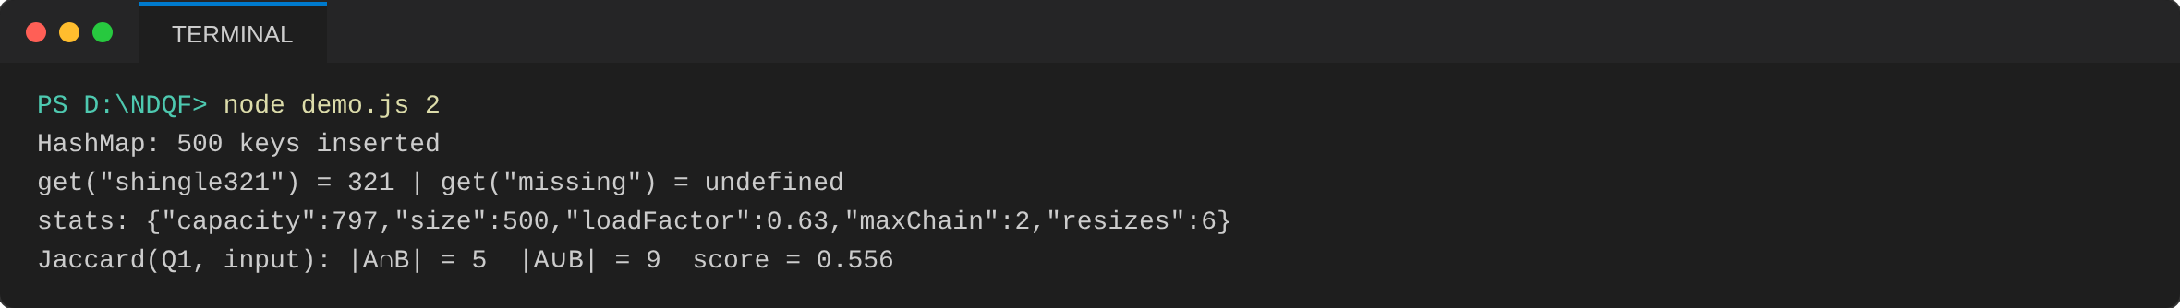
Figure 6.4: Module 2 output: HashMap statistics and Jaccard similarity
500 keys are stored with a load factor of 0.63 and a longest chain of 2 after 6 resizes; the Jaccard score of Q1 and the input is 5 ÷ 9 = 0.556.
Module 3: Inverted index and candidate retrieval (js/engine.js)
Every shingle hash is mapped to the list of questions that contain it. For a new question only its own shingles are looked up, so unrelated questions are never compared. Each candidate is scored with Jaccard similarity and offered to the Top-K queue.
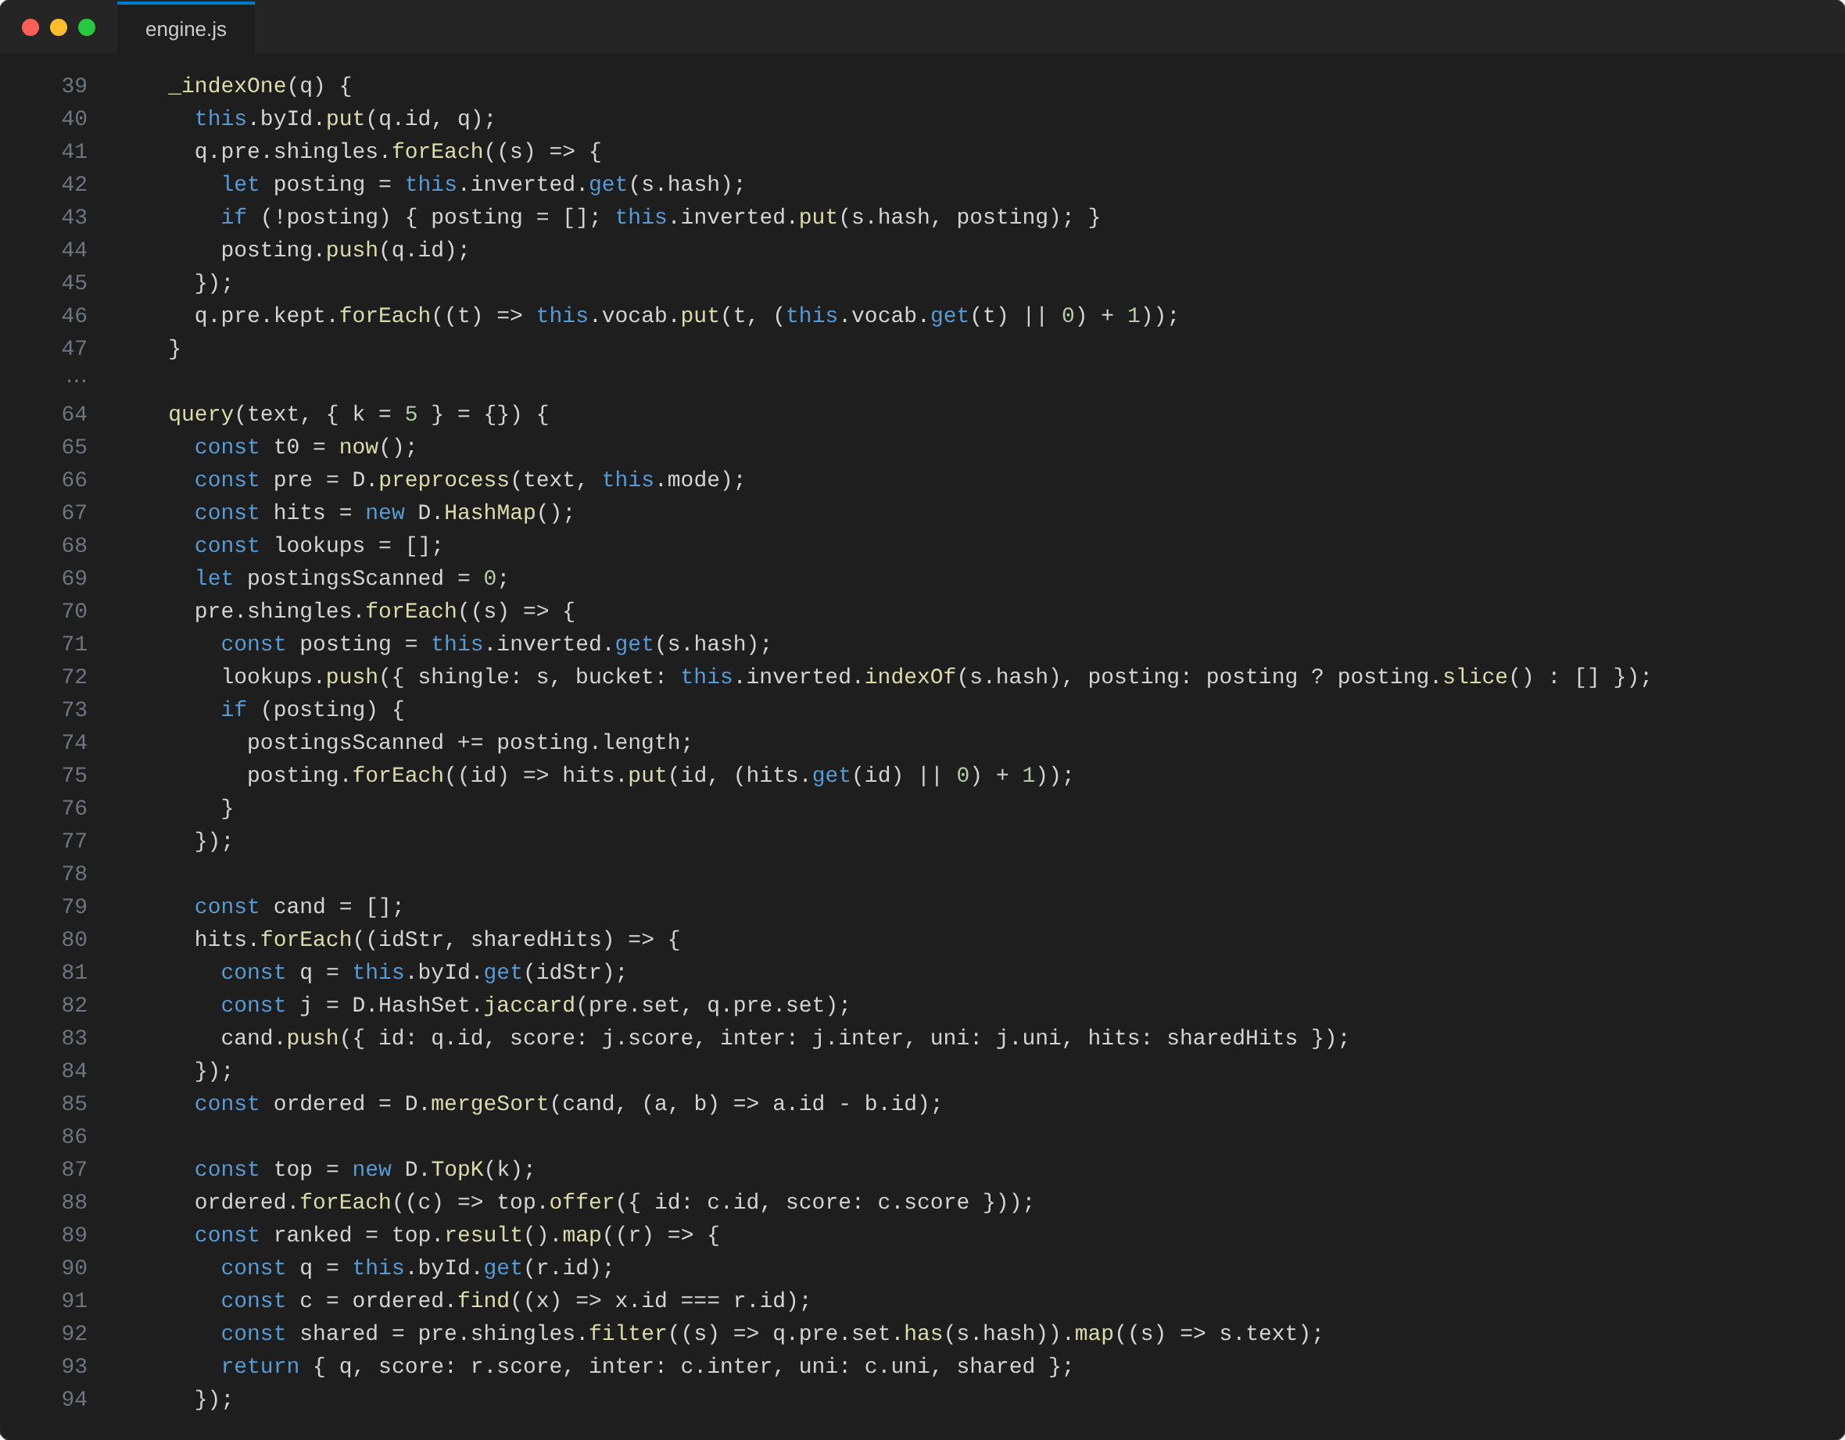
Figure 6.5: Source code of Module 3 (js/engine.js)
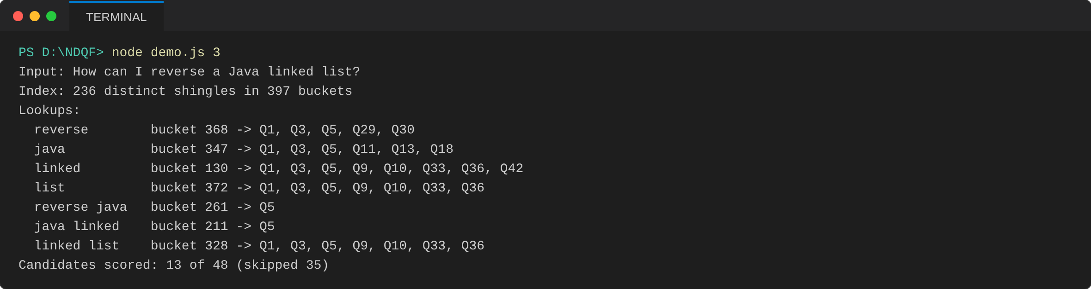
Figure 6.6: Module 3 output: inverted-index lookups and candidate retrieval
Each shingle is looked up in its bucket and lists the questions containing it; only 13 of the 48 questions become candidates and 35 are skipped.
Module 4: Priority Queue for Top-K ranking (js/ds.js)
A bounded min-heap of size K keeps the best matches seen so far. Its root is the weakest of them, so a new candidate only has to beat the root, which costs O(log K) per accepted candidate and O(1) for a rejected one.
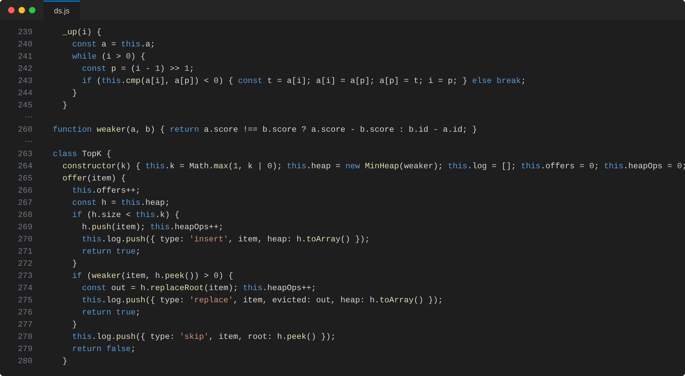
Figure 6.7: Source code of Module 4 (js/ds.js)
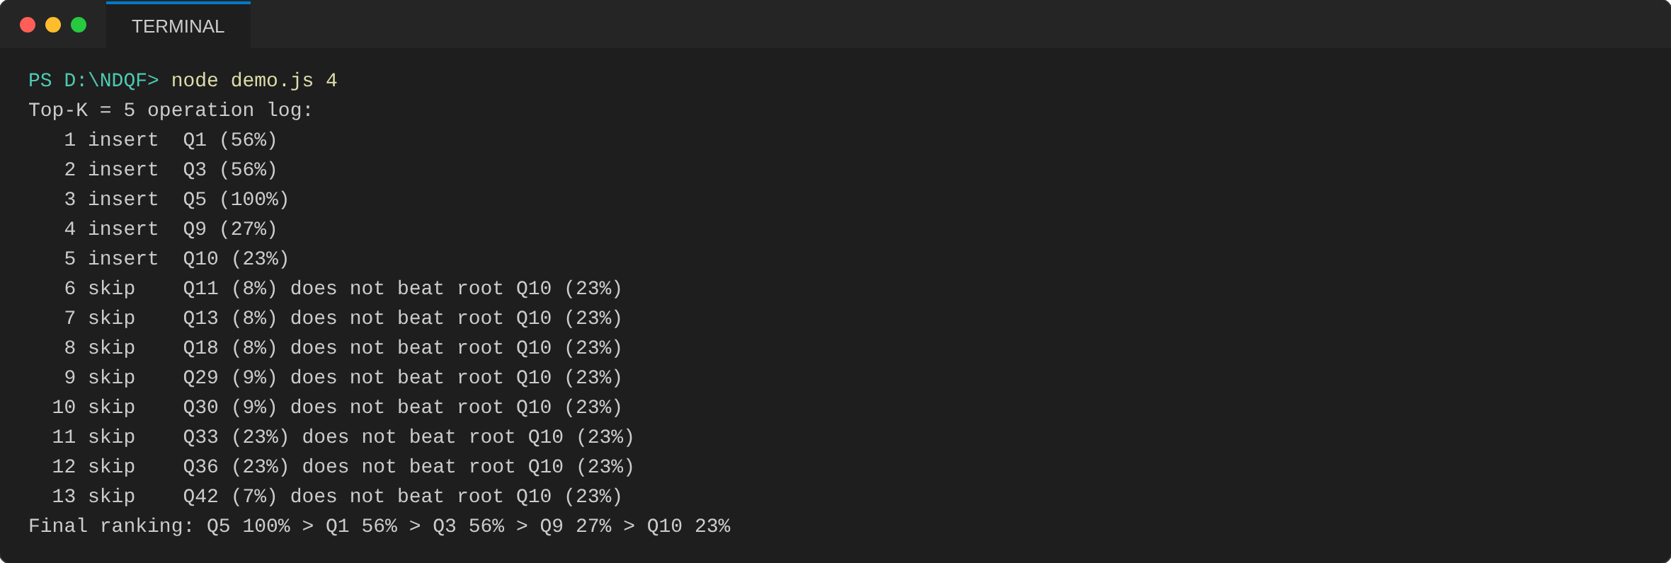
Figure 6.8: Module 4 output: Top-K heap operation log and final ranking
The first five candidates are inserted, the rest are rejected in O(1) because they do not beat the weakest root (Q10), giving Q5 > Q1 > Q3 > Q9 > Q10.
- RESULTS & DISCUSSION

The website was run in the browser with the 48-question seed database (questions Q1–Q4 are the worked example of the project presentation). The input question “How can I reverse a Java linked list?” was checked with the shingle mode “Words + word pairs” and Top-K = 5.
Rank | Question | Similarity | Shared ÷ Union
1 | Q5: What is the best way to reverse a Java linked list? | 100% | 7 ÷ 7
2 | Q1: How do I reverse a linked list in Java? | 56% | 5 ÷ 9
3 | Q3: How can I reverse a linked list using Java? | 56% | 5 ÷ 9
4 | Q9: How do I detect a cycle in a linked list? | 27% | 3 ÷ 11
5 | Q10: How to find the middle element of a linked list? | 23% | 3 ÷ 13

Only 13 of the 48 stored questions were scored, because only those share at least one shingle with the input. The indexed Top-5 was identical to an exhaustive scan of all 48 questions (13 versus 48 similarity computations, about 73% fewer).
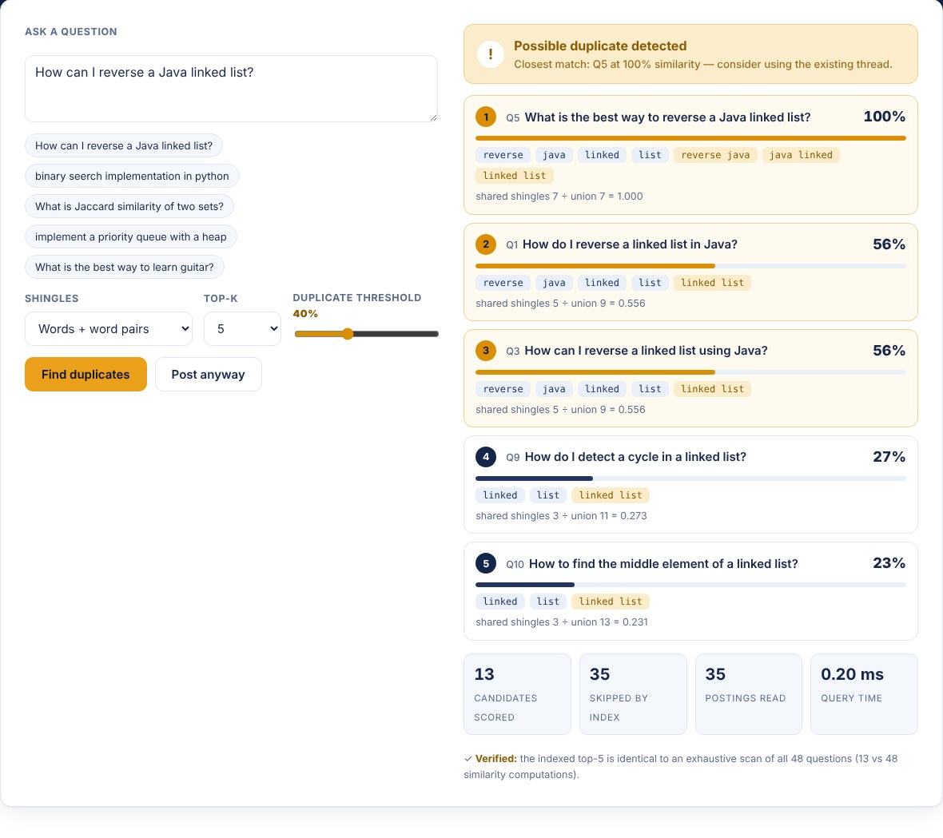
Figure 7.1: Duplicate detector – ranked results with shared shingles, similarity bars and statistics
The detector shows the closest matches with their Jaccard scores, flags a possible duplicate above the chosen threshold and reports how many candidates were scored and how many were skipped by the index.

Figure 7.2: Preprocessing pipeline – original, normalised, tokens, shingles and hash values
Every stage of preprocessing is displayed live: stop-words (how, can, i, a) are struck out, four tokens are kept and seven unique shingles are hashed to buckets of the index.
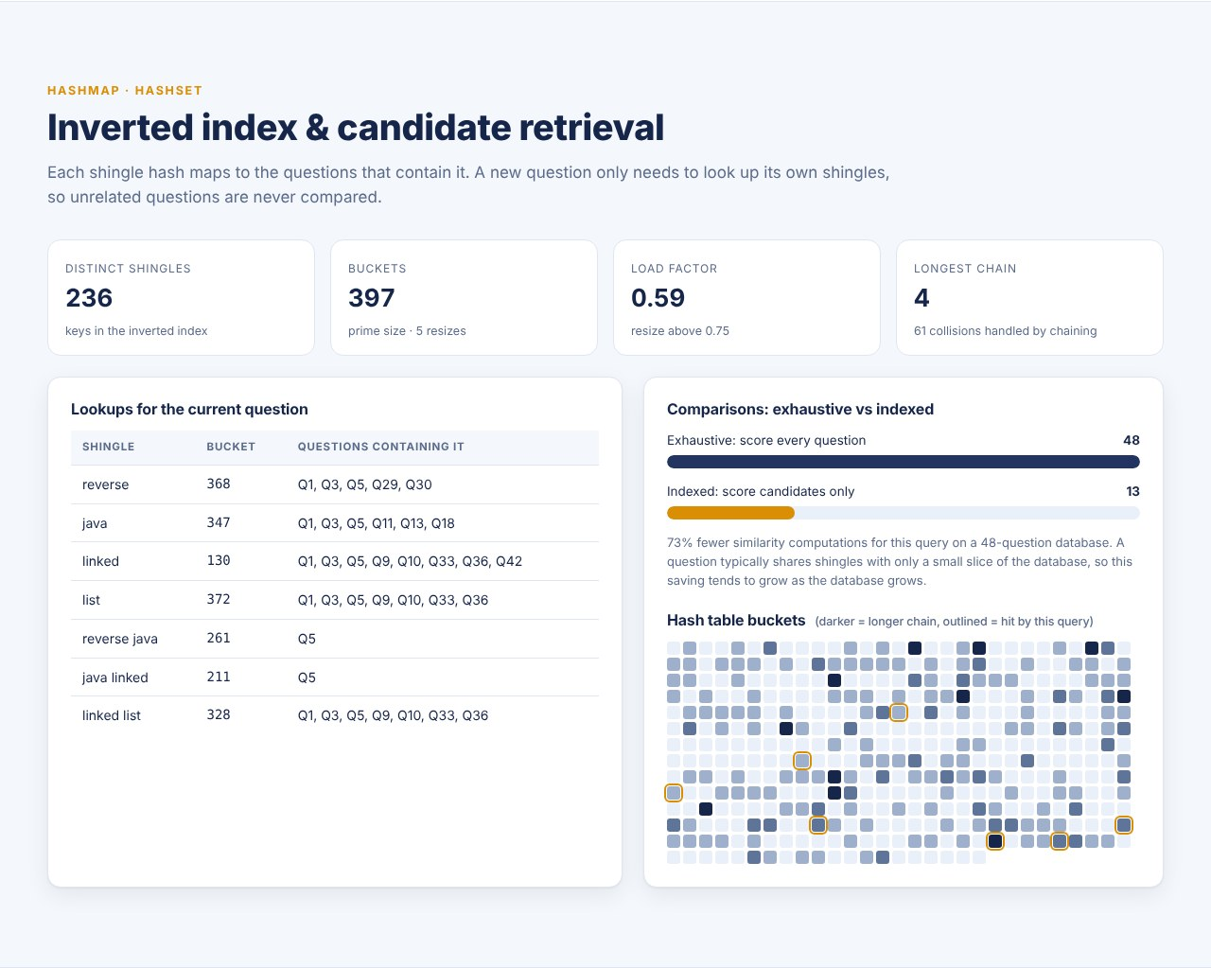
Figure 7.3: Inverted index and candidate retrieval (HashMap)
The index holds 236 distinct shingles in 397 buckets (load factor 0.59, longest chain 4). The comparison bar shows 13 indexed comparisons against 48 for the exhaustive method.
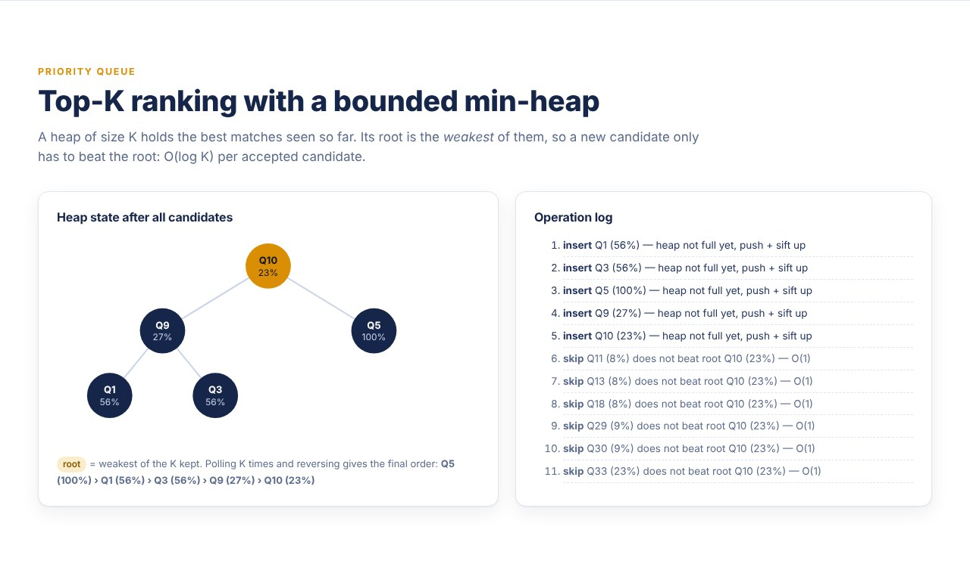
Figure 7.4: Top-K ranking with a bounded min-heap (Priority Queue)
The heap holds the five best candidates with the weakest (Q10, 23%) at the root; later candidates such as Q11 and Q13 (8%) are rejected in O(1) because they do not beat the root.
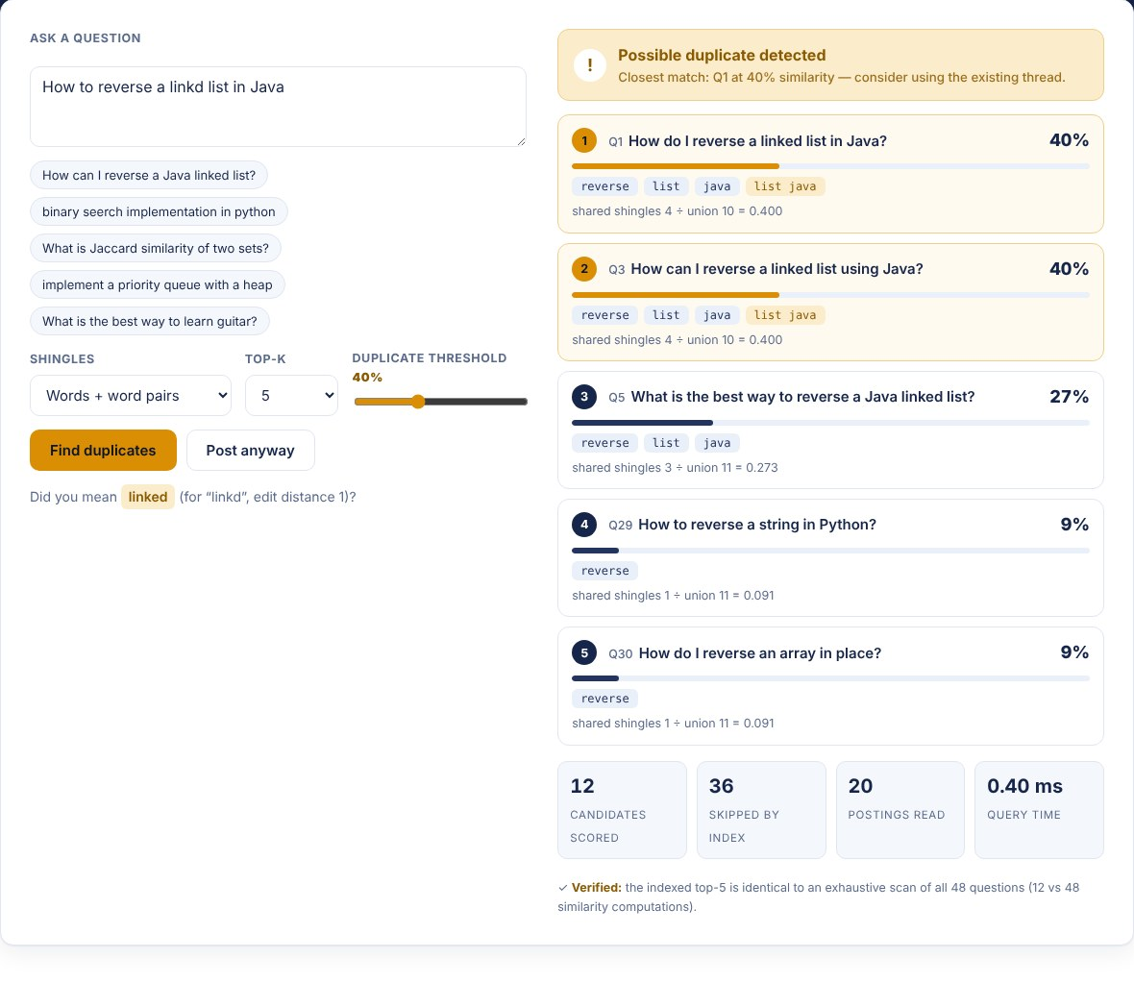
Figure 7.5: Misspelled query with “Did you mean” suggestion (edit distance)
For the input “How to reverse a linkd list in Java” the system suggests “linked” (edit distance 1) and still reports Q1 and Q3 as possible duplicates at 40%.
Discussion
The ranking matches intuition: the rewording of the same question (Q5, Q1, Q3) scores far above related but different questions (Q9, Q10), and unrelated questions are never scored. The scores depend on the chosen shingle mode: single words give higher scores to loosely related questions, while word pairs and triples give stricter matching. The percentages in the presentation (95%, 92%, …) are illustrative sample output, whereas the values above are the live results of the implemented system.
The 32 automated logic tests (node test/run.js) pass, including a check that the indexed result is identical to an exhaustive scan. A limitation is that Jaccard similarity measures word overlap, not meaning: fully paraphrased duplicates that share no words will not be found. Questions added by the user are stored in the browser’s localStorage only.
If a question is not present in the database
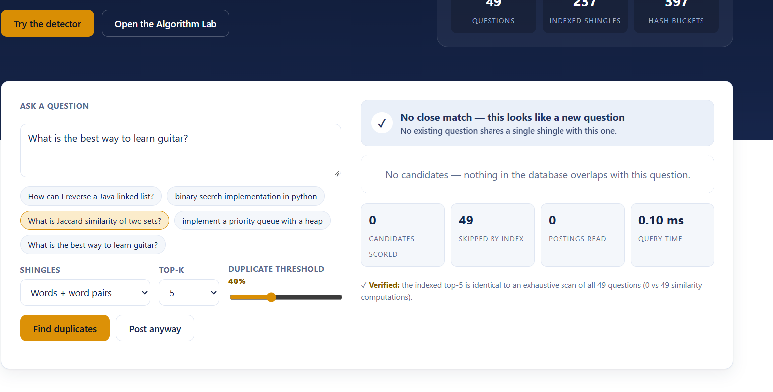
- CONCLUSION & FUTURE SCOPE

The project applied Data Structures and Algorithms to a real-world Q&A problem and met its objectives. Text preprocessing (normalisation, tokenisation, stop-word removal and shingling) gave every question a consistent set representation. HashMap and HashSet supported efficient indexing, candidate retrieval and set operations, Jaccard similarity measured how close two questions are, and the Priority Queue ranked the most relevant candidates. In the tests, the indexed search returned exactly the same Top-K as an exhaustive scan while scoring only 13 of 48 questions.
The system can therefore help prevent redundant questions by showing the user possible duplicates before posting. Our approach demonstrates how fundamental DSA concepts can be combined to solve a practical information retrieval problem.
Future Scope
Near term:
• MinHash – faster estimation of similarity (a first version is already demonstrated in the Algorithm Lab).
• Support for larger question databases with persistent storage instead of browser localStorage.
Medium term:
• LSH – scalable candidate retrieval for very large question banks.
• Semantic similarity and embeddings – understand meaning beyond word overlap and find paraphrased duplicates.
Long term:
• Machine Learning – intelligent duplicate classification.
• Multilingual support – detect duplicates across languages.
• Real-time, large-scale deployment on a live Q&A platform.
- REFERENCES

1. A. Z. Broder, “On the Resemblance and Containment of Documents,” 1997. https://www.cs.princeton.edu/courses/archive/spring13/cos598C/broder97resemblance.pdf
2. A. Z. Broder, S. C. Glassman, M. S. Manasse and G. Zweig, “Syntactic Clustering of the Web,” WWW6, 1997. https://archives.iw3c2.org/www6/proceedings/Technical/Paper205/Paper205.html
3. J. Leskovec, A. Rajaraman and J. D. Ullman, “Finding Similar Items,” in Mining of Massive Datasets, Cambridge University Press. https://www.cambridge.org/core/books/mining-of-massive-datasets/finding-similar-items/FDDA225F039792324F28D73D26950E89
4. Y. Zhang et al., “Multi-Factor Duplicate Question Detection in Stack Overflow,” Journal of Computer Science and Technology, 2015. https://jcst.ict.ac.cn/EN/10.1007/s11390-015-1576-4
5. M. S. Kale, A. Rayasam, R. Parik and P. Dheram, “Mining Duplicate Questions of Stack Overflow,” arXiv:2210.01637. https://arxiv.org/abs/2210.01637
6. S. Srivastava, “Identifying duplicate questions on Quora | Top 12% on Kaggle,” Towards Data Science. https://towardsdatascience.com/identifying-duplicate-questions-on-quora-top-12-on-kaggle-4c1cf93f1c30
7. “Siamese Neural Networks with Random Forest for detecting duplicate question pairs.” https://cs.paperswithcode.com/paper/siamese-neural-networks-with-random-forest
8. Stack Overflow Blog, “Handling Duplicate Questions,” 2009. https://stackoverflow.blog/2009/04/29/handling-duplicate-questions/

